# Scenario

* Build a script to create two types of Azure Storage, a blob and a table.
* Add sample data to both storage locations that can be used for the following exercise.
* Create code to run from your desired location (local, Azure Function, etc.) to retrieve the content from table and print it to the screen.
* Create code to run from your desired location (local, Azure Function, etc) to run from anywhere that will retrieve the content from the blob storage and save it to local disk.
* Be ready to discuss the best practices of Azure Storage.

# Code

Create console application

* VS 2017 -> New Project -> Visual C# -> Console App (.NET Framework)

# Output

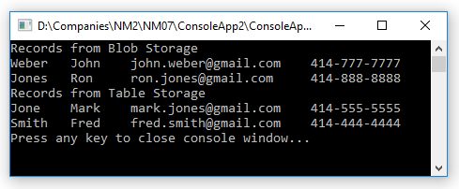

# Resources



# Details

|  |  |
| --- | --- |
| **Resource** | **Subscription** |
| Name | Free Trial |
| Subscription ID | 9f847037-9073-42ac-8cdc-6cfae23a6cab |
| Tenant ID | 4daa5164-f673-4721-a1b0-28d19ca8a964 |
| **Resource** | **Resource Group** |
| Name | nm07-rg01 |
| **Resource** | **Storage Account** |
| Name | nm07storage01 |
| Blob service endpoint | https://nm07storage01.blob.core.windows.net/nm07storage01blob01 |
| Table service endpoint | https://nm07storage01.table.core.windows.net/nm07storage01table01 |